Practical No.09
Configure and Verify a Site-to-Site IPsec VPN Using CLI
Network:
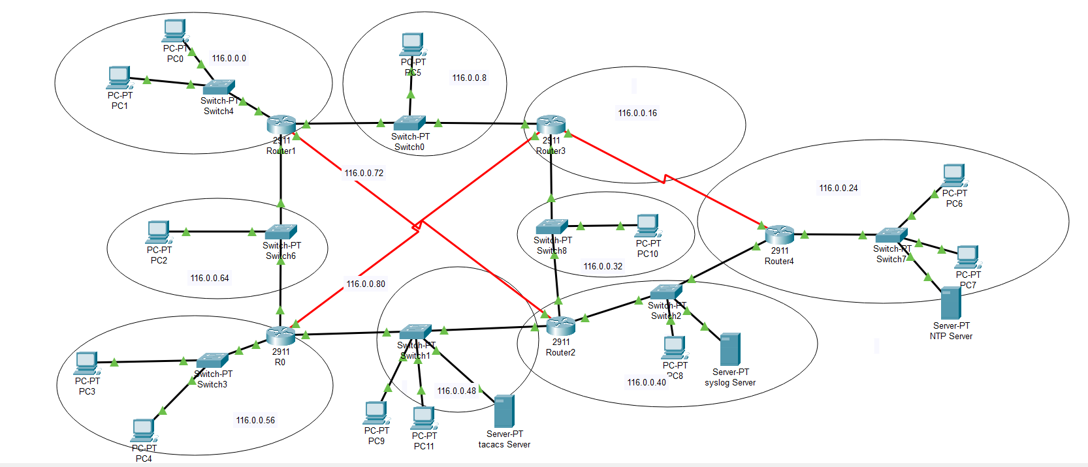
OSPF is configured before when the packet is sent from source to destination it shows the ip of particular pc when the packet is send
The packet is sent from PC2 to PC3
PC2 IP=101.0.0.10
PC3 IP=101.0.0.18
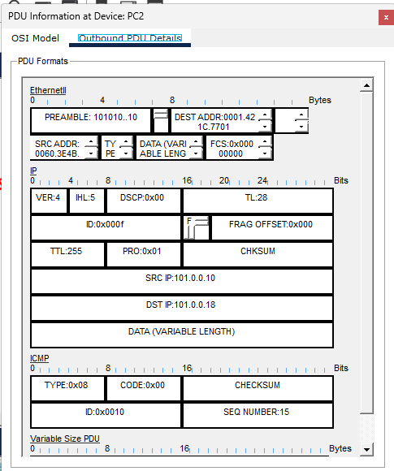
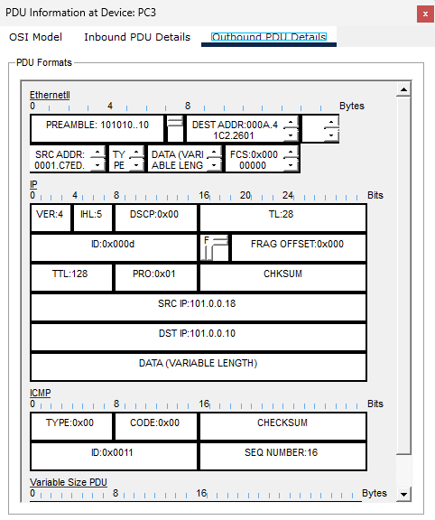
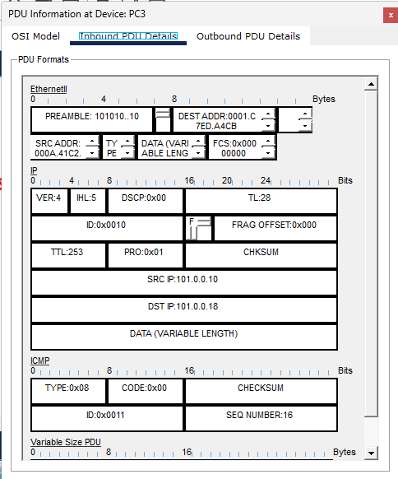

Configuring vpn on Router0 using the following commands:
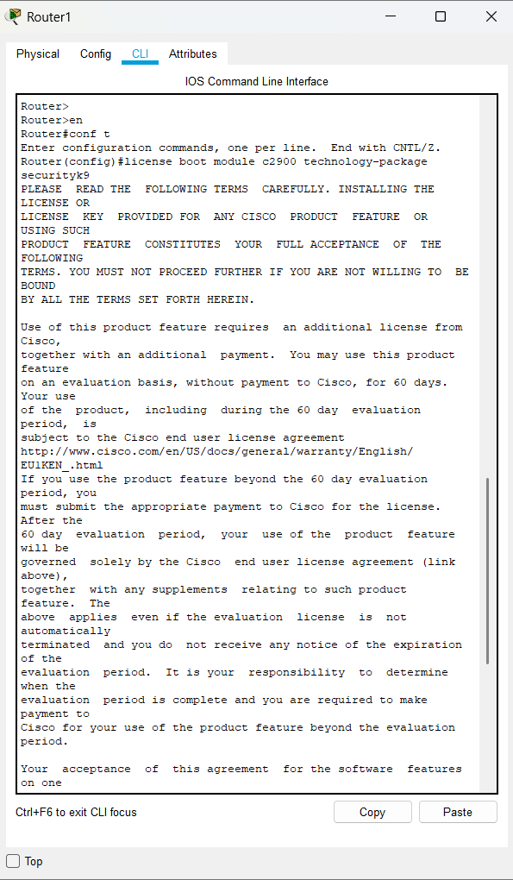
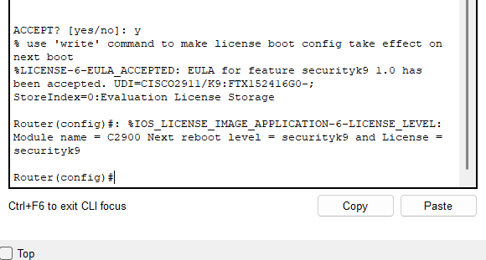
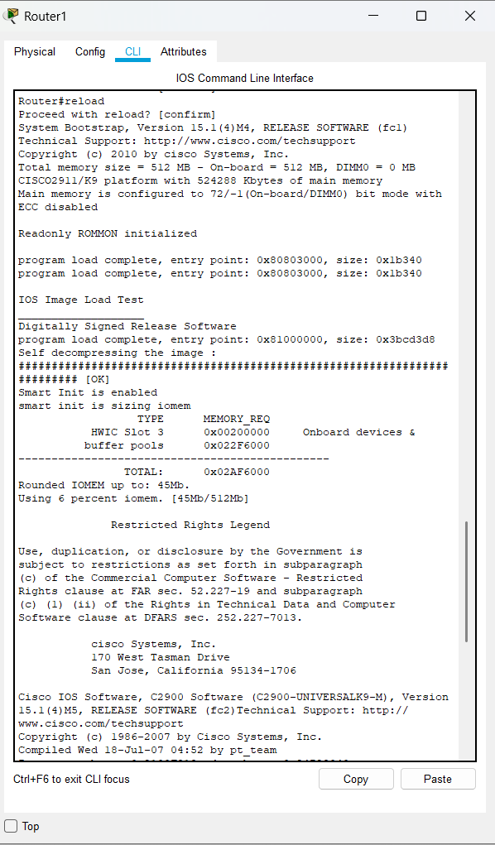

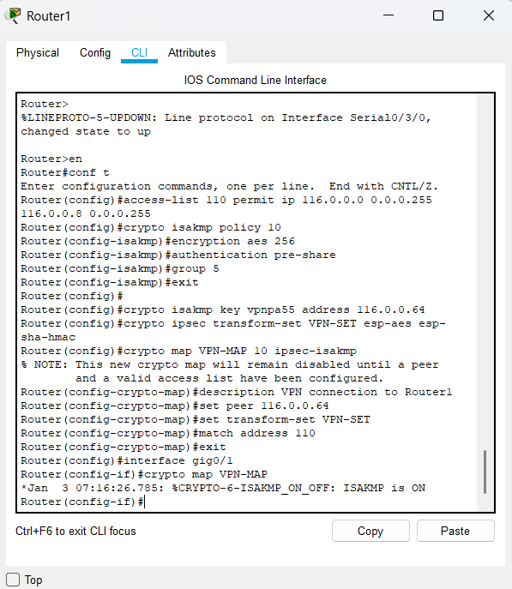

Configuring vpn on Router2 using the following commands:
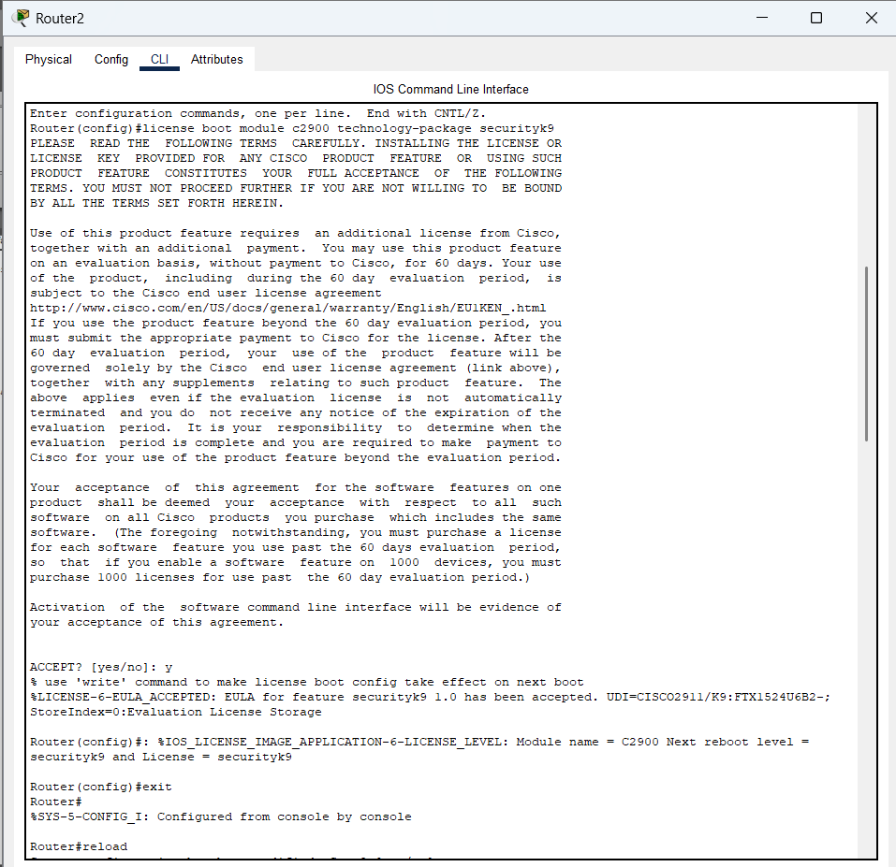 After Configuration of VPN,
packet show source IP and destination IP of interface from which route packet is routed
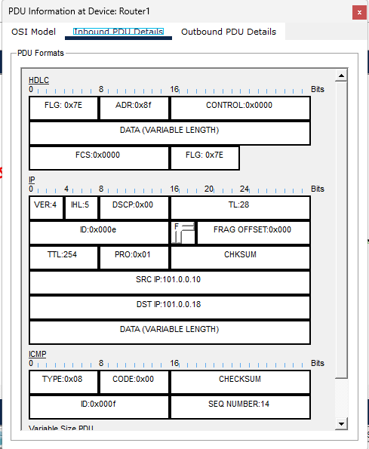
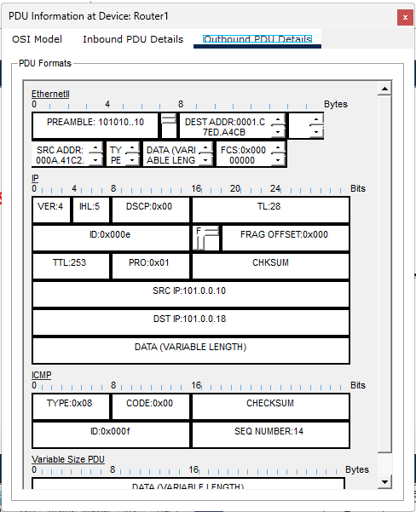
Pinging from PC0 with IP 101.0.0.18 which is inside the tunnel
